



SPONSORSHIP PROSPECTUS

This international congress aims to capture key technological advances in fields heavily dependent on membrane filtration systems such as water, air quality, biomedical sciences, microelectronics, biopharmaceuticals, chemical manufacturing, energy, and mining, oil, gas and power generation.

From an educational perspective, this meeting will review new synthetic routes of membrane and filtering materials formation. It will reflect on new approaches of merging academic and industrial research together and without compromising the quest for basic scientific advances.

From a socio-economic perspective, AMSIC-2 will seek to determine how filtration technologies can tackle more effectively practical challenges associated with better access to clean water, improved air quality, the processing of industrial and biopharmaceutical fluids by adopting environmentally friendly practices, and improved healthcare and patient protection.

FIELDS OF INTEREST:

Advanced materials fabrication & processes
- Synthesis of Advanced Porous Materials : membranes and fibrous materials
  - Composites and Nanostructures in Filtration
  - Surface treatment of polymeric and inorganic membranes
  - Nanofibrous materials
- Pressure-driven Membranes and Processes (MF, UF and NF)
- Reverse Osmosis and Pressure Retarded Osmosis,
- Depth Filter Media for Membrane Protection
- Catalytic Membranes and Membrane Reactors

Porous/fibrous materials & their applications
- Fibrous media for Water Treatment
- Fibrous media in Air Filtration & Air Quality
- Gas Separation
- Membrane for the Life Sciences (biomedical / biopharmaceutical fields)
- Membranes for Bio-fuel Applications and Sustainability
- Bioremediation and Analysis

Transport/filtration mechanisms - Hybrid & smart systems
- Membrane Fouling and Mechanisms
- Modeling/Theoretical Tools Applied to Membrane Formation and Transport Phenomena
- Hybrid Membrane Filtration Systems
- Pervaporation and Vapor Separation
- Membranes for Sensing and Electrochemical Applications
- Internet of Filtration Systems and Smart Materials
We would like to invite your company to become involved with this congress by choosing any of the options below.

Sponsorship classification | Sponsorship amount | Benefits
Platinum sponsor | R40 000 | - Your logo on the home page of the congress website with a link to your company’s website.  - Product flyers for inclusion in the congress bag.  - Two full A4 page colour adverts in the final congress programme book, one of which on the back cover.  - Registration for two company representatives at the congress.  - Promotional banner in the venue where plenary sessions will be held.  - One complimentary exhibition stand (table top) at the congress.
Gold sponsor | R30 000 | - Your logo on the congress website with a link to your company’s website.  - Product flyers for inclusion in the congress bag.  - One full A4 page colour advert in the final congress programme book.  - Registration for one company representatives at the congress.  - Promotional banner in the registration area.  - One complimentary exhibition stand (table top) at the congress.
Silver sponsor | R20 000 | - Your logo on the congress website with a link to your company’s website.  - Product flyers for inclusion in the congress bag.  - One A5 page colour advert in the final congress programme book.  - Promotional banner in the registration area.  - One complimentary exhibition stand (table top) at the congress.
Bronze sponsor | R10 000 | - Your logo on the congress website with a link to your company’s website.  - Product flyers for inclusion in the congress bag.  - Promotional banner in the registration area.  - One A5 page colour advert in the final congress programme book.
Invited speaker sponsor | Travel costs, accommodation for duration of visit, meals, consultation fee, if applicable | - Company name linked to session on programme.  - Invite speaker of your choice (international or local)  - Your logo on the congress website with a link to your company’s website.  - Registration for one company representatives at the congress.  - Promotional banners in the lecture hall.  - One A4 page colour advert in the final congress programme book.
Session sponsor | R20 000 | - Company name linked to session on programme.  - Opportunity to invite speakers for the session.  - Your logo on the congress website with a link to your company’s website.  - Registration for one company representatives at the congress.  - Promotional banners in the lecture hall.  - One A5 page colour advert in the final congress programme book.
Exhibition only (table top) | R8 000 | - Your logo on the congress website with a link to your company’s website.  - Acknowledgement in the congress programme book.  - Registration for one company representative to man the exhibition stand
Advertisement in programme book (colour) | R3 000 - A4  R2 000 - A5 | - Your logo on the congress website with a link to your company’s website.  - Advert
Flyer in delegate pack | R3 000 | - Your logo on the congress website with a link to your company’s website.  - Flyers supplied by you inserted in delegate packs.

Gift sponsorship (pens, USB's, note pads, lanyards, shirts, etc.) |  | - Benefits listed above of the same monetary value as the gift.

Requirements for Adverts
A5: 148 x 210 mm (orientation: landscape)
A4: 297 x 210 mm (orientation: portrait)
Convert text to paths/curves
300 dpi CMYK colours
5mm bleed all round
Saved as an Adobe Acrobat document (PDF)

Date for receipt of adverts, flyers, promotional material and sponsored items
15 July 2018
Address for delivery: 441 Charles Barret Street, The Willows, 0041, Pretoria

For more information please contact the Congress Secretariat
Thereza Botha

E-mail: thereza@technoscene.co.za
Tel: +27 12 807 0869
Fax: +27 86 549 0184
Mobile: +27 83 375 7373

Tel: +27 12 807 0869

M
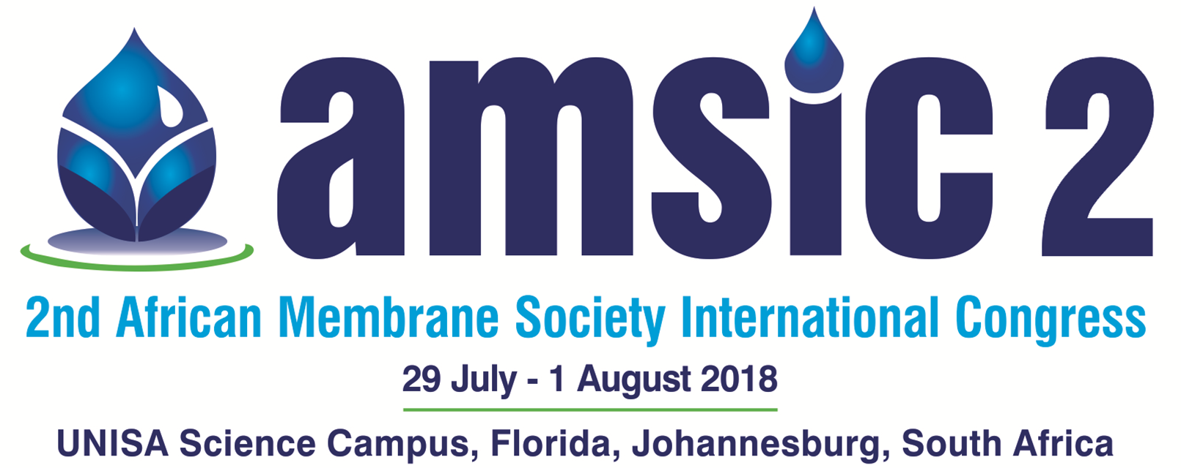

BOOKING FORM FOR SPONSORS AND EXHIBITORS

Name of Company
Postal Address
Postal town
Postal code
Country
Contact person
Telephone Code |  |  |  |  |  | Telephone number
e-mail address
Company VAT number
Company URL |  | http://www.
Sponsorship |  |  |  |  | Tick |  | Description
Sponsorship | Platinum package |  |  |  |  |  | R 40 000
Sponsorship | Gold package |  |  |  |  |  | R 30 000
Sponsorship | Silver package |  |  |  |  |  | R 20 000
Sponsorship | Bronze package |  |  |  |  |  | R 10 000
Session | Title: |  |  |  |  |  | R 20 000
Exhibition | Table top |  |  |  |  |  | R 10 000
 | Gifts (Please specify)
 | Advertisements |  | A5 colour |  |  |  | R 2 000
 |  |  | A4 colour |  |  |  | R 3 000
 | Flyer in delegate packs |  |  |  |  |  | R 3 000
Other (Please specify)
Signed |  |  |  |  |  |  |  | Date

Please fax to: +27 86 549 0184 or e-mail: thereza@technoscene.co.za
An invoice will be sent to you upon receipt of this form

